**SOUTH EAST MARTS – HAILSHAM MARKET**Primestock report for  
**Wednesday 5th August 2020**

**PRIME CATTLE (14) (UNDERAGE & OVERAGE)** *Auctioneer: Roger Waters*

Only lean feeding cattle forward under thirty months, Hye House Farms’ Simmental cross heifers

174p per kilo & Fleckvieh x Holstein steers 160p per kilo & £1001.70 per head. Chris Berry’s

over-age heavyweight Aberdeen Angus cross heifers gross £1260 and steers £1197.20.

**CULL COWS (9)** *Auctioneer: Roger Waters*

Once again all guns firing just not enough to satisfy their customers Christine & Robin Neale’s Simmental cross cow grosses nearly £1250! ie 147p per kilo. Ken Russell’s young Aberdeen Angus cross 148p per kilo. Welcome to RL & JC Pickering of Hadlow with their British Blue x Friesian 141p per kilo. Best of the Dairy the Pickering Family with their steaking Holsteins to 126p per kilo & £850 per head. We thank you all for supporting the live auction market at Hailsham.

**CALVES (0) *Auctioneer:*** *Roger Waters*

No calves on offer - bringing calves then please let us know

**PIGS () *Auctioneer:*** *Roger Waters*

Entered for next week, twelve Pietrain x store pigs, 12 weeks, gilts or castrated, also three Purebred Saddleback gilts, ten weeks old.

**SHEEP (973)**  Auctioneer: Nick Young

Gold is realising $2,000 an ounce!!

**MILK LAMBS (465)**  Overall average 202p per kilo

Other centres reported trade was back, the Hailsham trade was UP, especially for big meated lambs, small and storefied lambs look remarkable value by comparison.  All proper meated big lambs were battled from first to last.  Richard Russell of FP Russell Farms, Laughton Brooks takes top price at £118.50. The message is clear big lambs = a big price and a trade which others would understandably be envious of.

**Leading prices:** F P Russell Farms £118.50, £103, Trinidad Investments £114, £108, £101, Dunstars Farm £110, £98, Mrs D Sutton £110, R Hoggins £108, F G Coles £105, £98, C White £103, W&P New T/A Moorhouse Farm £102,  G Dallaway £99.50, A C Ellett £99, Mr K Axell £98

**Top prices per kilo:** W&P New T/A Moorhouse Farm 226.2p, 224.3p, 222.2p, R Hoggins 225.1p,  Trinidad Investments 223.5p, 217.3p, 216.7p,  F P Russell Farms 222.9p,  Mr K Axell 222.7p,  Rumsden Farm 219.1p,  Dunstars Farm 217.8p, 214.8p,  C White 217.3p,  AGL Ainslie 217.2p,  A C Ellett 215.2p,  R G Whyman Esq 213.7p

**CULL EWES (150)**

Numbers were back following the festival of Eid last week but trade rallied.  A superb run from Castle Goring Farm (Clem Somerset) take top price selling to £81 thrice. More ewes wanted but please note there is little demand for overfat or ultra plain ewes.

**Leading prices:** Castle Goring Farm £81, £81, £81, £67, Downsview Sheep £74, £68, £65,

C White £72, John Pile (Farms) Ltd £71, £66,  R Hoggins £65, John Marsh £60

**STORE SHEEP (351)**

There is no grass in the south east!!  Trade had to suffer and it did.  Biggest and best sell well, the smallest and worst do not.  However no complaints. S Levett top at £68

**Leading prices:** S Levett £68,  R G Whyman Esq £67,  N Bowie £65.50, D Van Duyne £65.50,

George Dallaway £65

*Next Week: 25 Texel cross store lambs & 20 Lleyn ewes*

**Store Cattle Sale**

**Wednesday 12th August 2020**

**Wednesday 12th August** 1.00pm and not before

**Some good entries forward**

**Including:** 49 Limousin cross and British Blue cross steers & heifers, 17/20 months,

from FS Major & Sons,

14 Hereford cross steers & heifers, 8/11 months from H Baker & Son,

9 Aberdeen Angus cross & Hereford cross steers & heifers,

21 months from CV & RP Neale,

17 Purebred Sussex steers, 24 months, from David Hole,

13 Friesian steers, 18 months, from A Tasker,

Sussex cows & Sussex cross stores from Mrs C Walker,

18 Purebred Limousin, 12/16 months from N Hicks,

16 Sussex cross steers & heifers, 14 months from A Spencer

9 Charolais cross steers & heifers, 15/21 months from Pat Woodley

**Early Breeding Sheep Sale**

**Inc. Rare Breeds Cattle & Goats**

**plus**

**Special Sale Section for the Southdown Breed**

**Great to see new faces around the ring all competing keenly - a colourful day**

**horned or polled, big or small**

**interest in all lots offered under the hammer.**

**Southdowns in the sunshine**

**A pleasure to offer them thank you to all the breeders**

**who supported our early Sheep Breeding Sale**

**CATTLE**

*Highland & Dexter competition for all*

**R Whittemore’s** Purebred Highland heifer **£600**

& Purebred Highland cow with heifer calf **£420**

**H Visser’s** Dexter bull **£560**

**K Woodhead’s** Young Dexter cow **£460**

**B Poland’s** Dexter cow with calf at foot **£360**

**SOUTHDOWNS**

*Always pleased to see them at Hailsham*

***Leading Prices***

**Southdown Rams**

E Sargent £300, £270, £240

**Southdown Shearling Ewes**

E Sargent £260

T Gorringe £190, £170, (twice), £150, £140 etc. etc

C Bull £150, £140, (twice)

**Southdown Ewe Lambs**

JE Harmer £125

D&SM Heaton £125, £100

WH & JE Murphy £90, (twice)

**Southdown Breeding Ewes**

JE Harmer £145, £135

G Horton £110, (four times)

P Ballard £105

**GOATS**

Goats are great some purchasers tell us

GA Verity’s British Alpine with nanny kids £260

Golden Guernsey with nanny kid £100

C Wells Angora cross kid £100

& not forgetting

Little Bonnie Baldock’s

Little Pygmy goat £55!!

**SHEEP RARE BREEDS AND COMMERCIAL**

**Leading Prices:**

**Shearling Rams**

MVA Rams

V Mile’s Hampshire £360

& Charollais £350

KV Potter’s Texels £300

H Hawkins’ North Country Cheviot £180

J Whine’s Border Leicester £120

**Non Scheme Shearling Rams**

N Balcomb & Son’s Beltex x Charollais £440, £350

& Charollais £350

A Goldsmith’s Suffolk £350

Emily & Charlotte Killick’s Texel£340, £310

J&S Wareham’s Beltex cross £340, £300, (twice)

Kay May & J Vockin’s Texel £200

Lucy Andrew’s Border Leicester £80

G Horton’s Herdwicks £65

**Ram Lambs**

N Page’s Beltex cross Texel £150

C Greenfield’s Dorset £180

L Andrew’s Kerry Hill £80

**Shearling Ewes**

J&S Wareham’s Blue Texel £170

K Manning’s Southdown cx Mule £140

L Andrew’s Kerry Hill £130

R Rogers & Sons’ Texel x Mules £120

& Suffolk cross Mules £115

S Baldock’s Swiss Valais £120

PJ Greenaway’s Romney £110

M Goodman’s Herdwick £100

**Breeding Ewes**

L Andre’s pedigree Kerry Hill £140

M Wickens’ Zwartble £110

G Tobbit’s Herdwick £90

G Horton’s Herdwick £80

A Duke’s Ryland £60

**Ewe Lambs**

Goodwood Estate’s Beltex cross £107.50

L Andrew’s Kerry Hill £95

J&S Shrubsall’s Badger Face £72

H Hobbs’ Southdown cross £70

***Store Lambs***

Rideout Farm’s Texel cross £69

JRV Wheatland’s Charollais cross £66

R Whittemore’s Llyens £62

A Duke’s Rylands £52



**Livestock Auctions/COVID-19**

**Updated 24th July 2020**

**Hailsham Market** from now on will be operating under standards agreed by DEFRA and The Welsh Government.

**Conditions which now apply to the sale of all Primestock, Cull Animals and Store Stock.**

**As from Monday 27th April**

**Similar conditions will also apply to the**

**Sale of Breeding stock**

**Ie Beef Cows and Calves, Ewes with Lambs at Foot**

**THIS IS NOT A RELAXATION OF EXISTING COVID 19 RULES/PROTOCOL ALREADY IN PLACE - JUST AN EXTENSION**

All Purchasers must register on entering the market.

Social distancing must be strictly adhered to, i.e. 2 metres apart around the sale ring or sale pens.

Gathering points MUST be prevented. Please wear face coverings in the market.

South East Marts will be implementing a “Drop & Go” policy for vendors. Vendors **MUST** remain in their vehicles on arriving at the marketand when delivering animals to the loading docks must stay in their vehicles, market staff will unload the vehicle and take animals to their sale pens.

Sale documentation **MUST** be collected by auctioneer’s staff from the vendors vehicle, vendors **MUST NOT** take paperwork to the market office or to the clerk at booking in points or enter the penning area.

We ask that all prospective buyers sanitise on entry to the market and again on exiting the market. Disposable gloves will be available to all.

Buyers on collecting their invoices from the market office do so only by adopting the two metre rule - we ask for simply that only one purchaser should collect their invoice in the   
usual queuing area.

Specific to Store Cattle Sales: Should any Store Cattle vendor wish South East Marts will facetime/video call the producer when their cattle are being offered through the auction ring so they can be party to sales from a safe distance.

Vendors and Buyers please abide by these regulations, do not jeopardise the continuation of Livestock Auctions during these difficult times.

**Livestock Auctioneers nationwide have assured the Government that Social Distancing will be applied at all times - Please abide by this**

We all wish to stay in business and we all wish to reduce the risk

of COVID-19 infection.

COVID 19 Track & Trace is now in operation

Should anybody that has been in the market test positive they will be required to identify contacts.

Contacts - ie.

someone within 1 metre of them with whom they have had

a face-to-face-conversation, had skin-to-skin physical contact, have coughed on, or been in other forms of contact within 1 metre for 1 minute or longer

someone within 2 metres of them for more than 15 minutes

someone they have travelled in a vehicle with - or has been

seated near them on public transport.



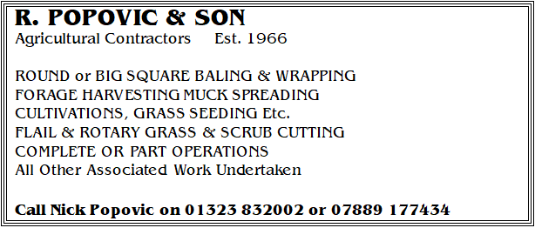

**FARM DIRECT**

**FODDER DIRECT**

2020 Fodder Season Bank - Buy now while you have the chance

Round bale hay

Round bale Winter Barley & Winter Wheat

Selling fast Lewes Area

~~~~~~~~~~~~~~~~~~~~~~

**BULL BANK**

**New on the market:** Aberdeen Angus bull three years plus,

TB One Pre movement tested can collect immediately

Young Limousin Bull Four Year TB Parish

Registered Aberdeen Angus bull

available to hire for the short term

~~~~~~~~~~~~~~~~~~~~~~

**BEEF CATTLE DIRECT**

 Four Purebred Highland Steers, 12 months

~~~~~~~~~~~~~~~~~~~~~~

**DAIRY DIRECT**

Seven Friesian bulling heifers, 22 months plus

Pictures & Breeding Available

Four Year TB Parish

Seventeen Friesian down-calving heifers

Four Year TB Parish

West Sussex

WE HAVE CUSTOMERS KEEN TO ACQUIRE

Friesian Holstein heiferS - Due to CALVE September

~~~~~~~~~~~~~~~~~~~~~~

**Tel: RRW 07860 663345 or 01323 844874**

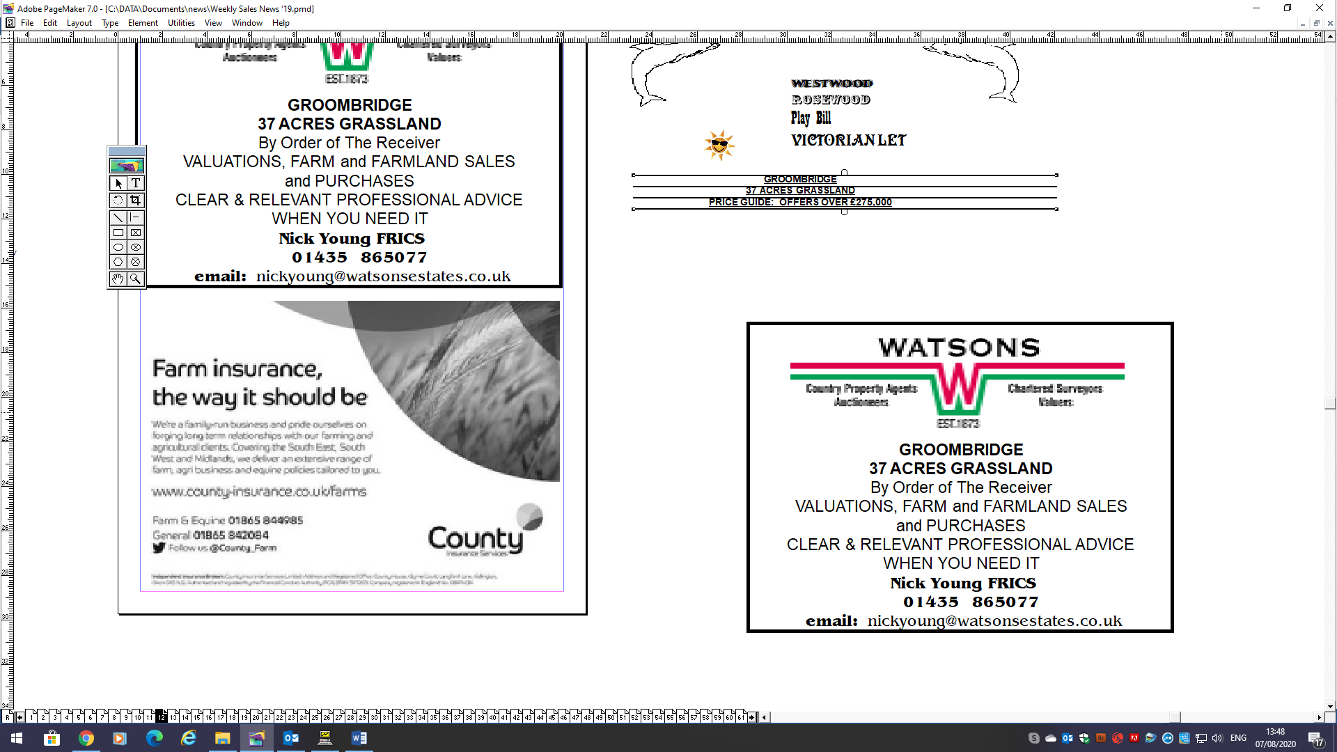

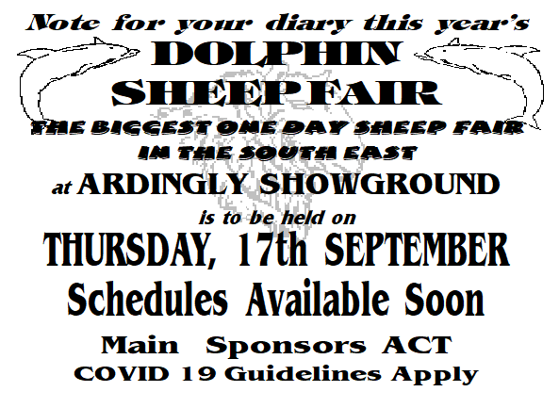







South East Marts

Market Street

Hailsham

East Sussex

BN27 2AG

01323 844874

07860 663345

[info@southeastmarts.co.uk](mailto:info@southeastmarts.co.uk)

[www.southeastmarts.co.uk](http://www.southeastmarts.co.uk)

